CSE 543- Computer Security



*Project 4: Web Security*

Date: December 7, 2022

Student Name: Md Rafi Ur Rashid

**Task 1.1**

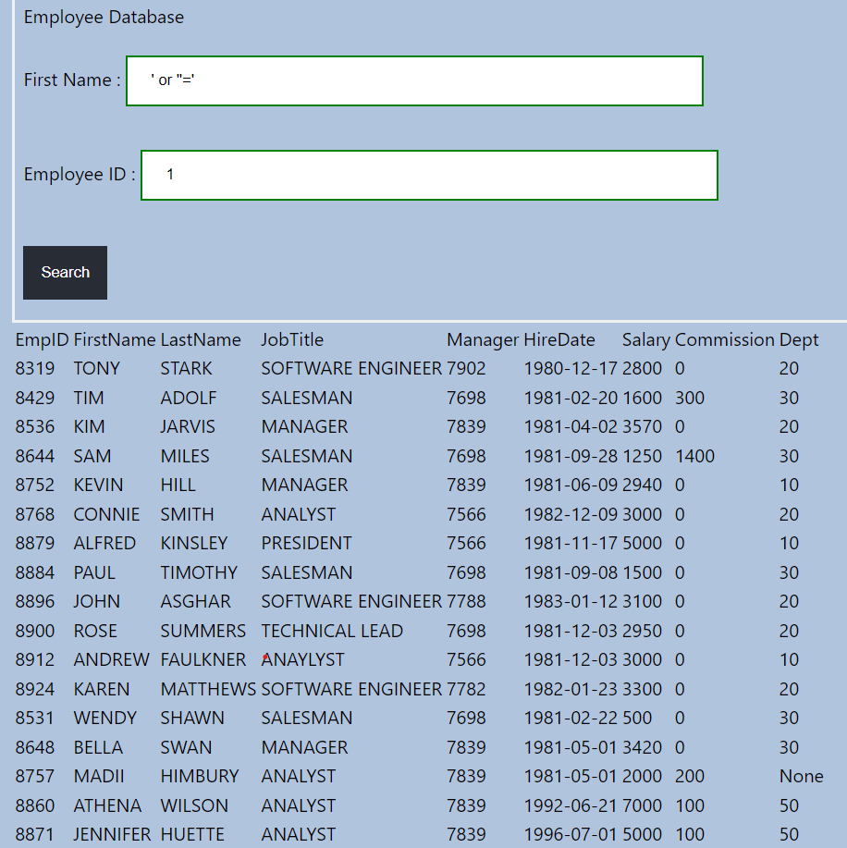

Tried to generate a sql of the following form to conduct the attack:

*Select * from EMPLOYEES where EmpID=1 and FirstName=‘’ or ‘’=‘’*

The *where* condition is true for each record.

**Task 1.2**

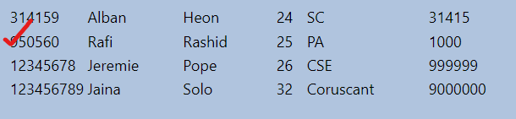

At first tried to find out how the original query looks like with some trial and error.

Then tried to append a second query for insertion at the end of the existing one. Which finally looks something like-

Select * from BANK where FirstName= ‘Rafi’ and Age=1 and AccId=1; INSERT INTO BANK VALUES (950560, 'Rafi', 'Rashid', 25, 'PA', 1000)

**Task 1.3**

Tried to create an always true condition and comment out the rest of the query:  
*Select * from EMPLOYEES where EmpID=EmpID # and FirstName=‘anything’*

**Task 1.4**

First of all I figured out the password column name with some trial and error. Then conducted a series of brute force/ intuitive guesses in a character-by-character manner. The crafted query somewhat looks like the following:

*Select * from LOGIN where username=’* *secret_user' and left( password, 10) = 'acrazylong' #*

**Task 2.1**

Pressed the login button and inspected the request payload in the network tab. Password has been passed in plaintext.

**Task 3.1**

I found that the value of the street address input is getting embedded as an HTML element (the hidden <div> in the above figure) when I register. So, I tried to utilize the HTML onerror attribute to trigger a sample script, and it seems to work. So, an attacker can execute malicious script (e.g., send user cookie to another origin) through XSS by exploiting this vulnerability.

**Task 3.2**

I just reused the idea from 3.1 and execute a script that send a GET request to the specified endpoint along with the user cookies.

**Task 4.1**

I took the request URL for registration by inspecting the network tab. Then used this as a form action in the crafted index.html. So the registration is forged from this html not from the original site.

**Task 4.2.**

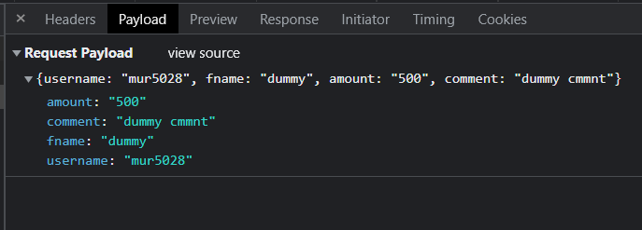

Like the previous task, I took the request URL for registration by inspecting the network tab. I also found that unlike the previous task, now the request body is taking json format. So, I observed the content-type in the request header and crafted a form in index.html in a slightly different manner. I tried to make sure that the name and value attributes of the input tag carry the whole json body combined. So, while submitting the form, now it sends a json object in the guise of form-data.